Lesson 4 – Inventory Levels and Customer Returns

Please make sure you watch all the screencasts on EMSLearn by clicking the "Next Page in Lesson" button (see the illustration below for reference).
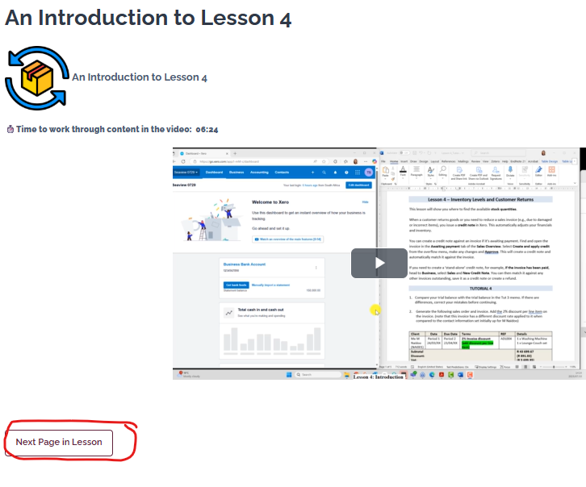

Inventory Levels
This lesson will show you where to find the available stock quantities.

Understanding Inventory Reports: List, Summary, and Details
Most accounting systems offer different related inventory reports. Xero provides the following three reports: Inventory Item List, Inventory Item Summary and Inventory Item Details. They all draw on the same underlying inventory data, but each is built to answer a different question.

- Inventory Item List — "What do we have, right now?"
This report is a snapshot as at one specific date. For each inventory item, it shows details such as the cost price, sale price, quantity on hand, and total value at that point in time. There's no movement or transaction history shown — it's simply a record of the stock position on that day. Think of it as a photograph of the warehouse shelf.

- Inventory Item Summary — "What changed over a period, in total?"
This report covers a date range rather than a single date. For each item, it shows the overall movement across that period — typically:
Opening Balance → Purchases → Cost of Goods Sold → Adjustments → Closing Balance → Sales
It gives one summarised line per item, so you can see the net effect of trading over the period (how much was bought, sold, and what's left) without wading through every individual transaction.

- Inventory Item Details: "What are all the individual transactions?"
This is the most detailed report, also covering a date range. Instead of one summarised line per item, it lists every single transaction that affected that item during the period: the date, the source document, the reference number, the customer or supplier, and the exact value and quantity movement for each transaction. It shows the full trail from the opening balance down to the closing balance, transaction by transaction.

How they relate
- The List is a snapshot: where things stood on one date.
- The Summary shows the net result of a period: the "before and after," totalled per item.
- The Details report shows the full working: every transaction that adds up to that net result.

Customer Returns
When a customer returns goods or you need to reduce a sales invoice (e.g., due to damaged or incorrect items), you issue a credit note in Xero. This automatically adjusts your financials and inventory.

You can create a credit note against an invoice if it’s awaiting payment. Find and open the invoice in the Awaiting payment tab of the Sales Overview. Select Create and apply credit from the overflow menu, make any changes and Approve. This will create a credit note and automatically match it against the invoice.

If you need to create a ‘stand-alone’ credit note, for example, if the invoice has been paid, head to Business, select Sales and New Credit Note. You can then match it against any other invoices outstanding, save it as a credit note or create a refund. In such cases, be sure to compare the credit note value to the original invoice to ensure it is correct and accounts for any discount.

TUTORIAL 4

- Compare your trial balance with the trial balance in the Tut 3 memo. If there are differences, correct your mistakes before continuing.

- Generate the following Inventory Reports and investigate what information each report generates and distinguish how they are different to one another.
Go to Reporting -> All Reports and select the reports below. Generate them for March 20XX.

- Inventory Item List
- Inventory Items Details
- Inventory Item Summary

- Generate the following invoice. Add the 2% discount per line item on the invoice. (note that this invoice has a different discount rate applied to it when compared to the contact information set initially up for M Naidoo)

Client | Date | Due Date | Terms | REF | Details
Me M Naidoo (NAI001) | Period 1  24/03/XX | Period 2  23/04/XX | 2% Invoice discount  (add discount per line item) | ADL004 | 1 x Washing Machine  1 x Lounge-Couch set
Subtotal  Discount:  Vat:  TOTAL |  |  |  |  | R 43 699.67  (R 891.83)  (R 5 699.95)  R 43 699.67

Write down the journal entries linked to the processing of the invoice.

Customer | 43 699.67
Sales |  | 37 999.72
Delivery Fee Income
Vat |  | 5 699.95
Discount taken
Cost of Sales | 22 075.00
Inventory |  | 22 075.00

- Three clients send back inventory, and you need to create three credit notes (credit memos for the returns). You will need to allocate the credit to the outstanding balance for each customer.

The customers that are returning stock are:
  - Me M Naidoo (Inv total R43 699.67),
  - Oceanview Furniture (R98 900.72) and
  - Me P Siyeni (R121 700.00).

To process a return, follow the steps below:
  - Go to Business > Invoices.
  - Locate and open the original sales invoice to which the return relates.
  - In the invoice, click "Create and Apply Credit" at the top right of the screen (kebab menu ⋮ ).
  - Xero will copy invoice details into a new credit note. Update:
    - Item(s) and quantity returned
    - Date of return
    - Add note: Returned due to damage
- Click Approve.
4.1
Client name | Date of return | Items returned
Me M Naidoo (NAI001) | Period 1  25/03/XX | 1 x Washing machine
TOTAL |  | R 7 918.40

Provide the journal for the transaction.
Customer
Sales
Delivery Fee Income
Vat
Discount taken
Cost of Sales
Inventory

4.2
Client name | Date of return | Items returned
Oceanview Furniture (OCE001) | Period 1  25/03XX | 1 x Dining Room – Chairs  1 x Washing Machine  1 x Toasters
TOTAL |  | R11 462.49

Provide the journal for the transaction.
Customer
Sales
Delivery Fee Income
Vat
Discount taken
Cost of Sales
Inventory

4.3

Client name | Date of return | Items returned
Me P Siyeni (SIY001) | Period 1  25/03XX | 1 x Toaster
TOTAL |  | R707.00

Provide the journal for the transaction.
Customer
Sales
Delivery Fee Income
Vat
Discount taken
Cost of Sales
Inventory

- Generate a report that displays the up-to-date inventory quantities and value (Inventory Value). Save the report generated (Inventory Item List Report).
- Generate a trial balance for the first period of the financial year and save the report.
- Generate a list of customers with transaction details for the first month of the financial year and save the report.

Reflection

Ensure that after the completion of this lesson, you can:
- Identify the available inventory quantities as well as the value of the total stock on hand.
- Understand how the inventory quantities change when a credit note (credit memo) is generated.
- Understand why the applicable amounts on the trial balance and customer balances have changed since you generated these same reports at the end of lesson 3.
- Understand how to identify the financial entries that correspond with the source document (credit memo) that you processed.

